

Asset Practice Questions: Science

**1. Some rivers in North India flow all-round the year. These rivers are called perennial rivers. Where do they start from?**

**A.** Ocean

**B.** The rain water

**C.** Rivers of ice called glaciers

**D.** Huge lakes of salty waters

**2. Which of the following foods is an important source of roughage?**

**A.** Rice

**B.** Wheat

**C.** Dal / Pulses

**D.** Vegetables

**3. Which of these means of communication was invented first?**

**A.** Letters

**B.** Television

**C.** Radio

**D.** Telephone

**4. Look at the picture given below. What is the main function of the organ pointed by the arrow?**

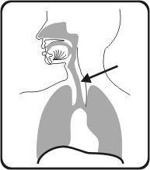

**A.** Carrying food

**B.** Carrying blood

**C.** Carrying messages

**D.** Carrying air

**5. Which process that happens in a tree is shown in this picture?**

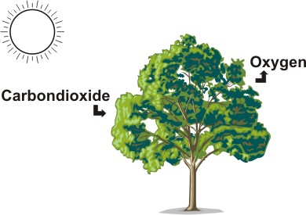

**A.** Making of food

**B.** Breathing

**C.** Resting

**D.** Losing water

**6. Sushila has brown eyes. The following people in her family have brown eyes. Whom could Sushila have got her brown eyes from?**

**A.** Her niece

**B.** Her sister

**C.** Her daughter

**D.** Her grandmother

**7. A baby chicken grows inside an egg for 21 days before it hatches. Where does the baby chick get its food before it hatches?**

**A.** It is fed by the mother hen.

**B.** It doesn't need any food.

**C.** It uses food stored in the egg.

**D.** It eats the egg shell.

**8. In many countries, on the main roads, people are encouraged to use cycles to travel. Which of these could be the MAIN reason to encourage people to use cycles?**

**A.** Cycles are very cheap.

**B.** Cycles cannot travel very fast.

**C.** Cycles do not pollute the surroundings.

**D.** Cycles do not need an engine to operate.

**9. A harmful effect of burning waste material in open spaces is that _________**

**A.** It will cause a big fire.

**B.** It causes air pollution.

**C.** It can cause injuries to those standing around.

**D.** The burnt material cannot be used.

**10. Why are nights usually cooler than days?**

**A.** Because the moon's light cools the parts that have night

**B.** Because the light from the stars cools the parts that have night

**C.** Because the parts having night are not facing the Sun

**D.** Because at night, the Earth is further away from the Sun

**11. Kalpana sees a plane taking off at the airport. From where does the plane get energy to fly?**

**A.** From its wings.

**B.** From its fuel.

**C.** From the wind.

**D.** From its wheels.

**12. Gita is giving hints about an animal organ and Harini has to guess what the organ is. Here are the hints given by Gita. This organ allows air to enter into the body. It is present both in humans and fishes. Which of these could be the organ Gita was talking about?**

**A.** Lungs **B.** Gills **C.** Eyes

**D.** Mouth